# Capstone Planning Document – Minotaur’s Maze

## Description:

This project will be a throwback to one of my favorite projects in the Nanodegree program, the maze.

The experience will place the user at the entrance to a large maze, where the user must complete a series of puzzles, fighting off the minotaur’s minions, and escaping the minotaur. Upon completion of the maze, the user will be allowed to complete it again, to catch all collectibles.

## Requirements:

The capstone requires completion of various achievements. Plans are summarized below.

1. Fundamentals (500 pts required)
   1. Scale Achievement (100 pts)
      1. During a selection of the puzzles, the user will have to activate a “zapping device” that shrinks the user to a size small enough to allow them to pass through certain portions of the maze (as an alternate path).
   2. Animation Achievement (100 pts)
      1. Doors/puzzle objects will be animated. Along the minotaur and its minions.
   3. Lighting Achievement (100 pts)
      1. Mixed Lighting lighting will be used.
   4. Locomotion Achievement (100 pts)
      1. T~~he Vive-Teleporter package will be used for locomotion in-game.~~ The same teleport locomotion effects will be used from the Night at the Museum Project
   5. ~~Physics Achievement~~
      1. ~~Physics will be required to complete some of the puzzles, similar to the Rube Goldberg Project~~
   6. Video Player Achievement (2x100 pts due to lighting)
      1. ~~A secret room will have videos from previous projects.~~ There will be a video at the beginning of the maze illustrating the user should stay away from certain baddies.
   7. Empathy Achievement (100 pts)
      1. The baddies will chase you around. The boss, the “CyberMinotaur”, eventually comes back from the grave, and is much faster each time.
2. Completeness (500 pts)
   1. Gamification Achievement (250 pts)
      1. ~~Each puzzle completed earns a higher score. The higher score will be doubled if each path is completed during the second pass through the maze (the “master level”).~~  The HUD displays the player’s score. As the gems are collected and baddies killed, the score goes up.
   2. Diegetic UI Achievement (250 pts)
      1. The scene will be designed to be intuitive to navigate. Objects in the maze will be simple and straight-forward to operate.
   3. Alternative Storyline Achievement (250 pts)
      1. Two paths will be available to the user. The user will have the opportunity to use both in the 2nd level.
   4. AI Achievement (250 pts)
      1. The minotaur and its minions will chase the player.
   5. 3d Modeling Achievement (250 pts)
      1. Homemade models from previous projects will be used.
   6. ~~Photogrammetry Achievement~~
      1. ~~Photogrammetry will be used to make some of the in-game collectibles.~~
3. Challenges (500 pts)
   1. User Testing (2x250 pts due to >750 pts in Completeness)
      1. Two tests near the final completion stage to determine that it is both intuitive and fun.
   2. Compute Shader Achievement (500 pts)
      1. Compute shaders used on Gems, Teleporters, and Position Locator
      2. ~~A compute shader will be used for the “zapping device”~~
   3. ~~App Store Achievement~~
      1. ~~This will be put on Steam Greenlight.~~

## Assets Required:

To expedite the development, 3rd party assets and models will be used. These include:

1. ~~Vive-teleporter~~ [~~https://github.com/Flafla2/Vive-Teleporter~~](https://github.com/Flafla2/Vive-Teleporter)
2. Minotaur Model <https://www.cgtrader.com/free-3d-models/character/fantasy/minotaur-cda47223-1a94-4f7d-bc2b-82344547726d>
3. The VR Samples Asset Pack <https://www.assetstore.unity3d.com/en/#!/content/51519>
4. Various sound packs – TBD
5. Google Blocks – Used to develop the 3d model of the trees at the beginning and exit
6. Gem model (see readme.md)

## Scripts/Whiteboard Drawings

Maze Layout:

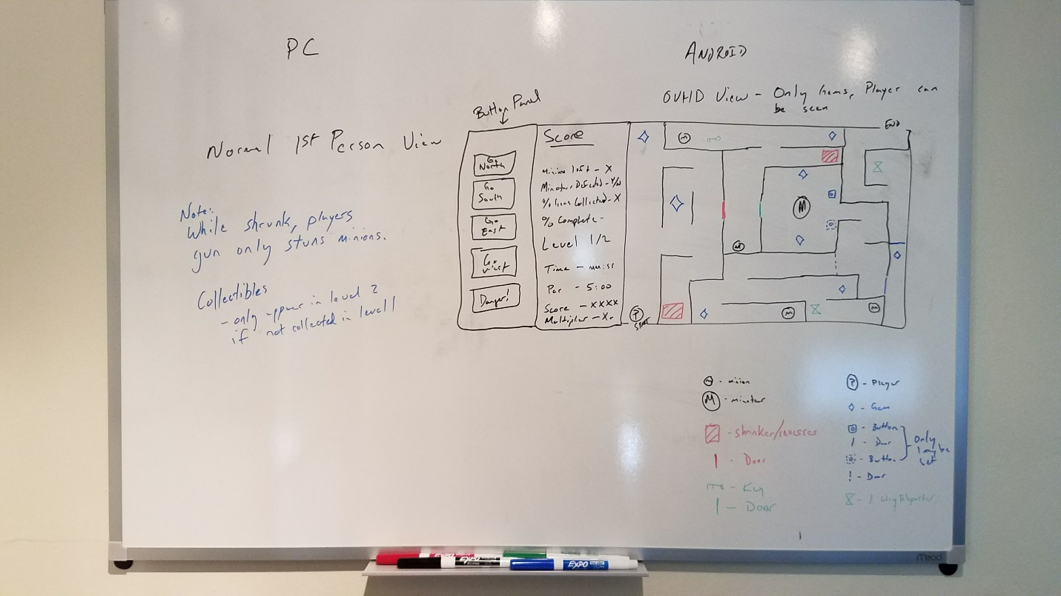

First Person View:

